**VAIBHAV RAJPAL**

**2020146**

Ans 1:

**3x3 Median Filter:**

**5% Corrupted:**

**Noisy:**

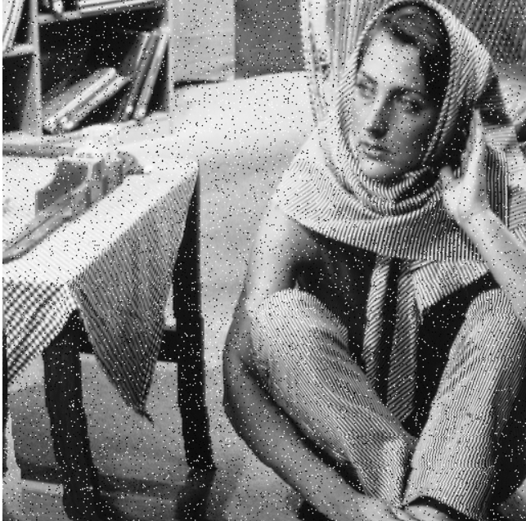

**Best Denoised Image:**

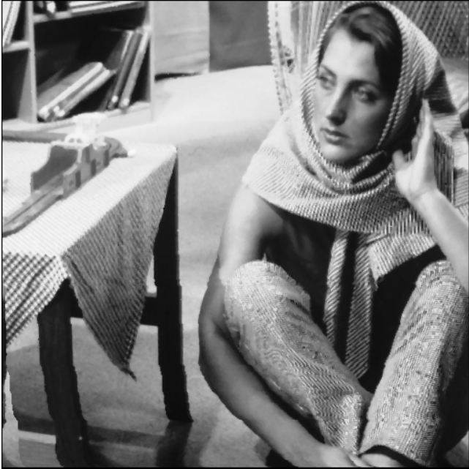

**15% Corrupted:**

**Noisy:**

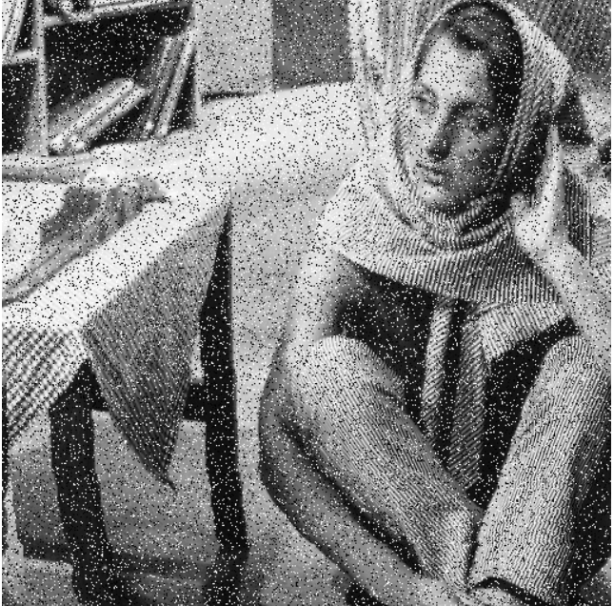

**Best Denoised Image:**

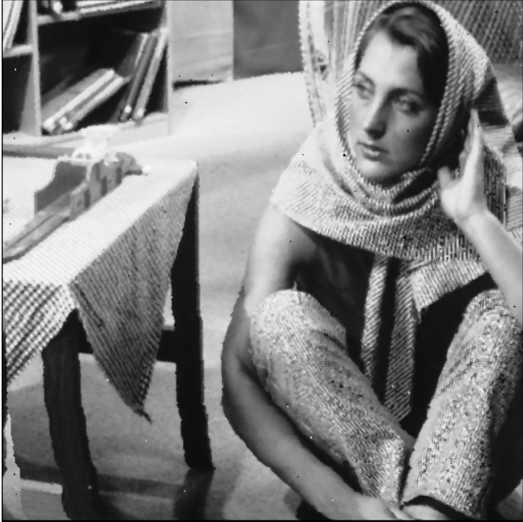

**20% Corrupted:**

**Noisy:**

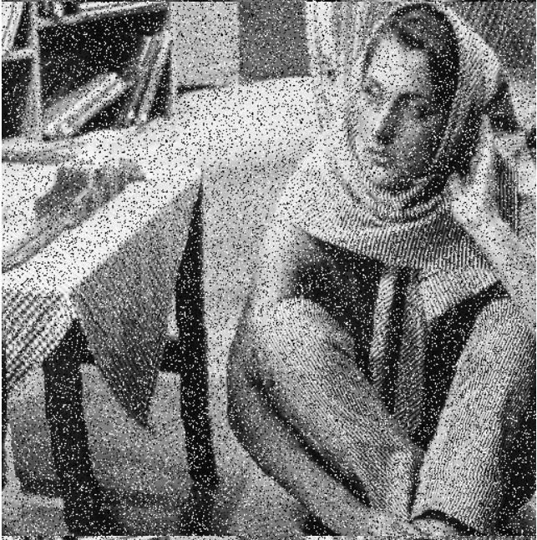

**Best Denoised Image:**

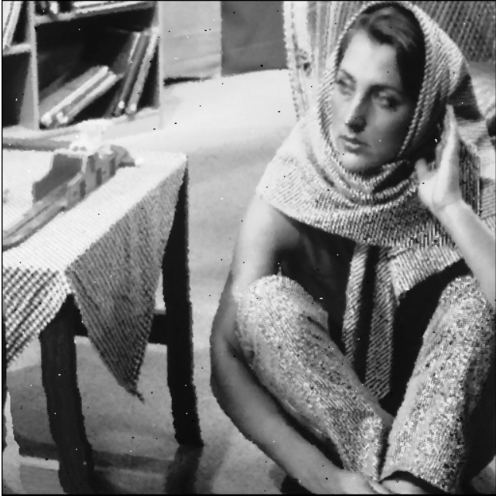

**25% Corrupted:**

**Noisy:**

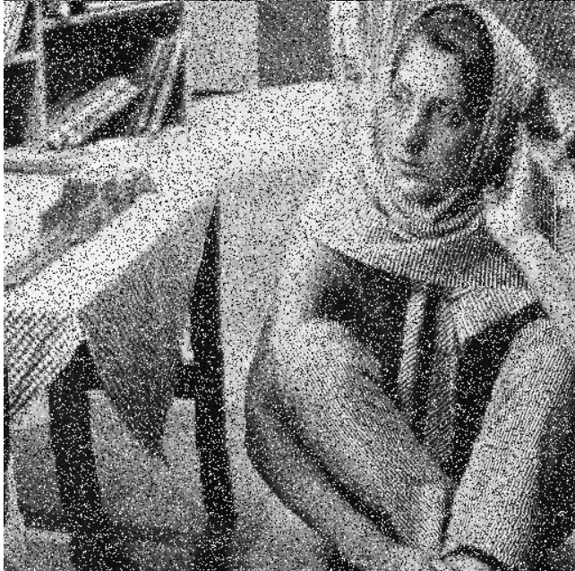

**Best Denoised Image:**

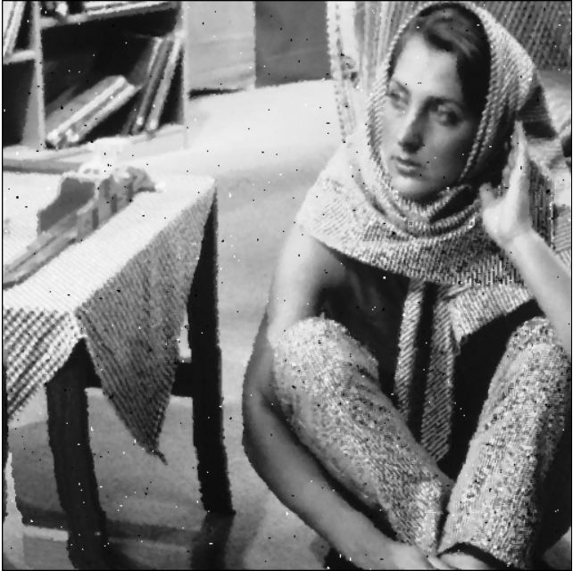

**PSNR:**

**5% Corrupted Pixels:** 21.197008982771052

**15% Corrupted Pixels:** 20.698934859437223

**20% Corrupted Pixels:** 20.33193419207995

**25% Corrupted Pixels:** 19.96375517789337

**5X5 Median Filter:**

**5% Corrupted:**

**Noisy:**



**Best Denoised Image:**

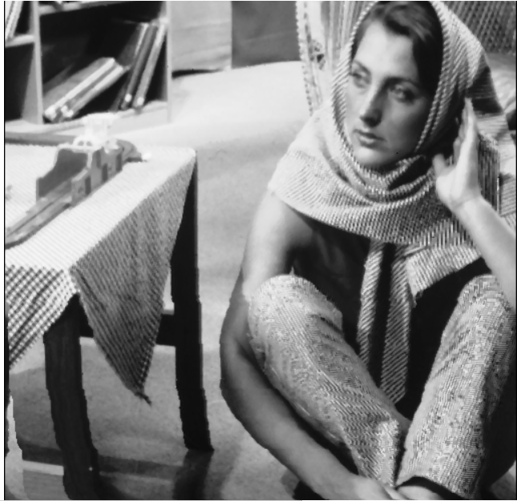

**15% Corrupted:**

**Noisy:**



**Best Denoised Image:**

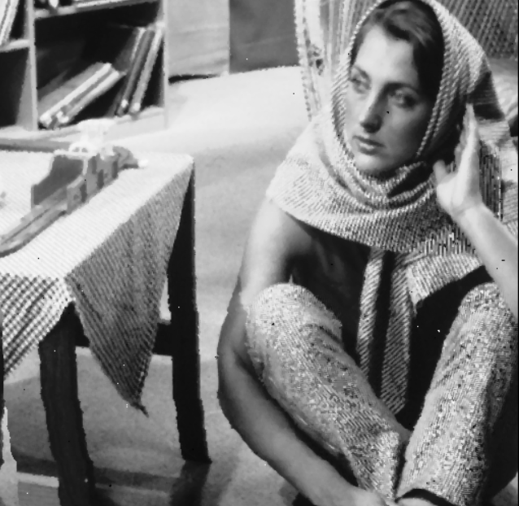

**20% Corrupted:**

**Noisy:**



**Best Denoised Image:**

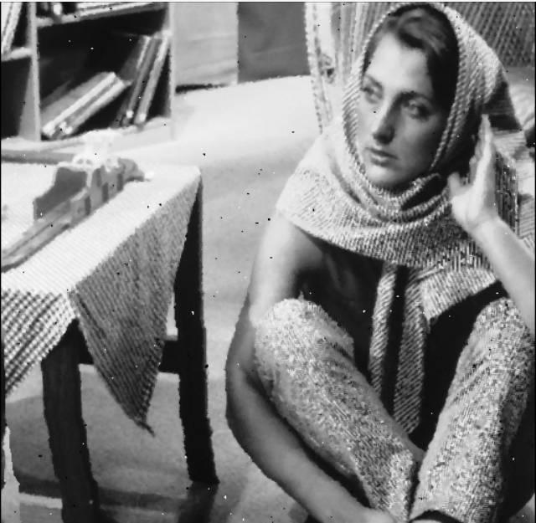

**25% Corrupted:**

**Noisy:**



**Best Denoised Image:**

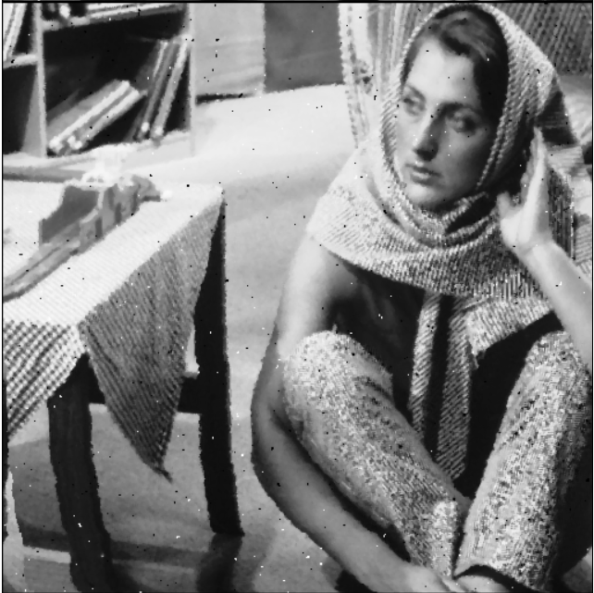

**PSNR:**

**5% Corrupted Pixels:** 18.76713194133925

**15% Corrupted Pixels:** 18.66212442014761

**20% Corrupted Pixels:** 18.597080143600138

**25% Corrupted Pixels:** 18.54478969273091

Now from the PSNR values for various corruption pixel values for various window size of 3x3 and 5x5, we can conclude that the window size of 3x3 is better.

Ans 2:

**Nearest Neighbour:**

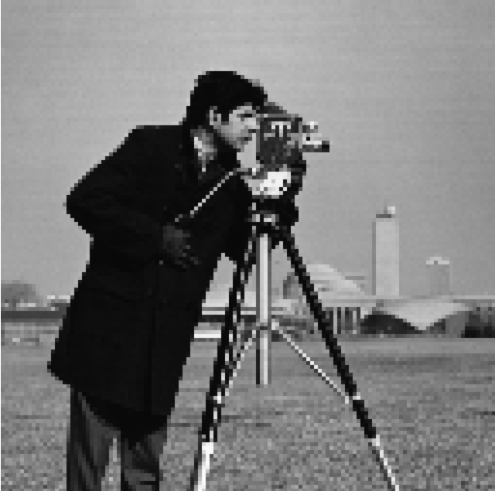

**PSNR:** 32.49076427109166

**Bilinear:**



**PSNR:** 25.087212669691255

**Bell:**

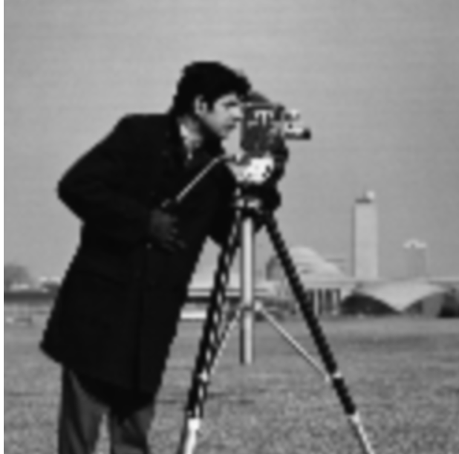

**PSNR:** 19.87524701427126

**Hermite:**

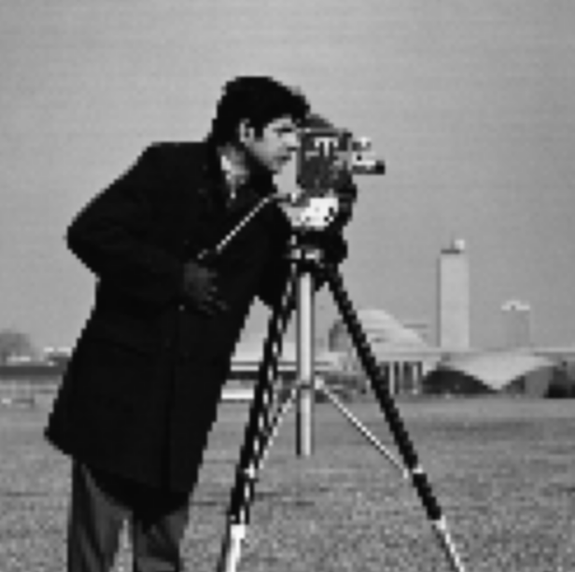

**PSNR:** 19.226351829251726

**Bicubic:**



**PSNR:** 32.1893852888092